Technical Design for Gameplay Manager

Revision History

Issue | Date | Person | Reason
0.1 | March 14, 2002 | Darryl Long | Created
1.0 | April 12, 2002 | Darryl Long | Reviewed by team and released

Description

Introduction
The Mission Manager controls the entire gameplay session during a mission game. It is responsible for loading and unloading the data, figuring out which files needs to be loaded and when, and reacting to the player’s actions in regard to mission specific data.

Requirements

- maintain a script of missions for a level
- load and dump mission data
- respond to and send mission related events
- watch trigger volumes
- set up other game managers (e.g. the mission-specific vehicles) for the mission
- stores a starting location
- designer can choose which “mission stage” should be used for restarts
- provides stats on the current mission
- provides data about previous missions (descriptions, player ratings)

References

- Talked to the Coders about Mission Manager design
- Design Document
- Mission Design Document
- Talked to Chuck about GUI requirements

Technical Design

Relationships

The Mission Manager loads a “world overlay” that is applied to the existing world data. Objects, vehicles, characters, camera animations, NISes and any other resources specific to the mission are loaded from a file and added to the world.

The Mission Manager must interface with the LoadManager, telling it to load a file or set of files. The Mission Manager does not need to communicate directly with the World Manager as the addition of WorldObjects is handled through the loading code. This includes the mission’s vehicles, which are associated with other Managers (e.g. Physics) at loading.

When the Player Character is loaded the Mission Manager must give the Character Manager a reference to the Player Character.

The Mission Manager needs to register itself with the Event Handling code for a set of events specific to the Missions planned events.

Some other component needs to tell the Mission Manager when it is time to load a new level. At that time, the Mission Manager loads a “level script” which contains all the missions (and references to mission scripts) for the new game level.

The HUD will use the Mission Manager for many things. If there is no collecting component to the mission, then the collectibles count is not displayed. Similarly, the time-left display, objectives and so on are only shown when appropriate to the current mission or mission stage.

The Mission Manager must be able to tell the LoadManager which heap and which inventory section to use.

The Mission Manager must be able to tell other managers to reset their local data about a mission object (for instance, a vehicle gets reset to the default state and its physics data needs to be reset).

Interface

Objectives

An objective is the basic goal of part of a mission. If a mission consists of several steps, then each step has a single Objective.

enum ObjectiveTypeEnum
{
OBJ_GOTO,
OBJ_DELIVERTO,
OBJ_DELIVERFROM,
OBJ_FOLLOW,
OBJ_DESTROY,
NUM_OBJECTIVES
}

class Objective //: public EventListener
{
public:
Vehicle GetRequiredVehicle();
TriggerVolume GetTriggerVolume();

bool IsFinished();
virtual void Update( float elapsedTime );

virtual void HandleEvent(whatever);
};

class GoToObjective : public Objective
{
public:
};

enum DeliverTypeEnum
{
DELIVER_TO,
DELIVER_FROM,
NUM_DELIVERTYPES
};

class DeliverObjective : public Objective
{
public:
WorldObject GetCollectible(unsigned int index);
unsigned int GetNumCollectibles();
DeliverTypeEnum GetDeliverType();
};

class FollowObjective : public Objective
{
public:
WorldObject GetTarget();
};

class DestroyObjective : public Objective
{
public:
WorldObject GetTarget();
};

Conditions

Conditions are the events that can signal the failure or success of a mission step. If a mission step has a condition, and the condition is not met, the mission fails.

enum ConditionTypeEnum
{
COND_PLAYER_VEHICLE_DAMAGE,
COND_PLAYER_HIT,
COND_TIME_OUT,
COND_PLAYER_OUT_OF_VEHICLE,
COND_OUT_OF_BOUNDS,
NUM_CONDITIONS
};

class Condition
{
public:
ConditionTypeEnum GetType();
void SetType(ConiditonTypeEnum type);

unsigned int GetDescriptionIndex();
unsigned int GetFailMessageIndex();

bool IsViolated();
virtual void Update( float elapsedTime );

virtual void HandleEvent(whatever);
};

class TimeOutCondition : public Condition
{
public:
unsigned int GetTime();
void SetTime( unsigned int time );

unsigned int SetStartTime( unsigned int time );

virtual void Update( float elapsedTime );
virtual void HandleEvent(whatever);
};

class VehicleCondition : public Condition
{
public:
Vehicle GetVehicle();

virtual void HandleEvent(whatever);
};

class DamageCondition : public VehicleCondition
{
public:
unsigned int GetMinValue();
void SetMinValue( unsigned int value );

virtual void HandleEvent(whatever);
};

class OutOfBoundsCondition : public Condition
{
public:
virtual void HandleEvent(whatever);
};

Mission Stages

A mission stage is a single step in a mission. It has both a single Objective and one or more Conditions. The Objective must be satisfied and the Conditions must be met for the mission stage to be successful.

class MissionStage
{
public:
unsigned int GetNameIndex();

virtual void HandleEvent(whatever);

Objective* GetObjective();

unsigned int GetNumConditions();
Condition* GetCondition(unsigned int index);

void Initialize();
void Finalize();

void Reset();

virtual void Update( float elapsedTime );
bool IsSuccessful();

unsigned int GetStartMessageIndex();
unsigned int GetEndMessageIndex();
};

Missions
A mission consists of a group of mission stages. The player progresses sequentially through the mission stages, and when the last stage has been completed successfully, the mission is considered complete.

class Mission
{
public:
unsigned int GetNameIndex();

Stage* GetStage(unsigned int stage);
unsigned int GetNumStages();

unsigned int GetCurrentStage();

char* GetScriptName();

void Initialize();
void Finalize();

void SetToStage(unsigned int index);
void NextStage();
void ResetStage();
void Reset();

virtual void Update( float elapsedTime );
bool IsComplete();
};

Managers
A gameplay manager is used to track and monitor the progress of a gaming session. The mission manager is used for the mission gameplay mode (or story mode). A mission spans the entire gameplay experience of the player in a single level.

struct PlayerData
{
unsigned int numMissionCollected;
unsigned int timeLeft;
};

enum RatingEnum
{
RATING_DNF,
RATING_BRONZE,
RATING_SILVER,
RATING_GOLD,
NUM_RATINGS
};

struct LevelData
{
unsigned int numMissions;
RatingEnum rating[ MAX_MISSIONS ];
unsigned int missionNameIndex[ MAX_MISSIONS ];
};

struct GameData
{
unsigned int numLevels;
LevelData levels[ MAX_LEVELS ];
unsigned int levelNameIndex[ MAX_LEVELS ];
};

class GameplayManager : public EventListener
{
public:
unsigned int GetNumPlayers();
PlayerData* GetPlayerData( unsigned int index );

void LoadLevelScript(char* name);
GameData* GetGameData();

unsigned int GetNumBonusCollected();
unsigned int GetNumBonusCollectibles();

Mission GetMission();
};

class MissionManager : public GameplayManager
{
public:
virtual void Update( float elapsedTime );
virtual void HandleEvent();
};

Component Class Diagrams
The MissionManager class loads a “level script” when instructed via the LoadLevelScript method. This sets the internal state of the MissionManager to “initialize” and the Mission Manager automatically loads the data for the first mission in the level script.

A mission script is a set of instructions for loading the mission objects, the objectives of the mission stages, and the conditions for failure in each stage. Also, the mission script has the name of the mission to follow each mission. A level script has the name of the first mission.

The Mission Manager has a pool of two Mission objects and an “Index” member to identify which mission in the pool is currently being used. The Mission Manager always has two missions loaded entirely to facilitate seamlessly switching between missions. Each of the two missions has a separate inventory section and heap to reduce search times and fragmentation.

At the beginning of a level, during the first loading, only the first mission is loaded. During the beginning presentation of this mission, the second mission is loaded. When the first mission is completed, the first mission remains in memory so the player can continue driving (or walking) in Sunday Drive mode. He may require the vehicle from the previous mission to get to the start of the next mission. Once he reaches the start of the second mission, and the presentation for the second mission begins, the first mission is dumped from memory.

During the presentation of the second mission, the first mission is dumped and the third mission is loaded. This continues on until all the missions in the level are complete. The Mission Manager must be able to tell the LoadManager which heap and which inventory section to use. Specifically, the Mission Manager sets the Heap and Inventory Section of the WorldObjectFactory singleton.

A Mission object queues its data for asynchronous loading with the LoadManager when the Initialize method is called by the MissionManager. The MissionStage::Initialize method is then called by the Mission objects to place the objects required by this mission stage in the default position. Some missions or stages will have “bindings” to world objects (such as a draw bridge) that existed when the mission was loaded, but were not enabled. This binding allows the mission to control and reset the already existing World Object.

Initially, all objects and disabled and hidden. When MissionStage::Initialize is called, the objects used in that mission stage are made visible and enabled. For example, an AI controlled vehicle will not move or consume any CPU cycles until it is enabled.

Once the first mission stage is complete the next mission stage is considered active. The Mission maintains the stage index as the state of the current mission. When the Mission Manager decides that the current objective has been satisfied, it calls Mission::NextStage to proceed to the next stage. If the stage fails then Mission:ResetStage is called to reset the status of the stage (e.g. moving objects back to their default position). If a mission fails entirely, all completed stages up to the current stage can be reset with Mission::Reset. Both Reset and ResetStage call MissionStage::Reset to place the objects used by the stages in the default position.

The player may want to be reminded the purpose of his mission. The game can read the MissionStage::GetStartMessage to display a hint. As an example, “Go to Moe’s Tavern.” Further, the game can read the Condition::GetDescription method for more information about the conditions for failure, such as “Get there in less than 60 seconds”. The MissionStage::GetEndMessage is displayed upon successful completion of the mission stage, and the Condition::GetFailMessage is display if a condition is violated.

The Mission Manager waits for events from trigger volumes and other managers to track the progress of a mission. For instance, if the Objective of the current mission is to wait for a message from the “Mission1End” trigger volume, then when that message is received Mission::Next is called. If one of the Conditions of the mission is to finish before the time reaches zero, and a “Time Is Zero” message is received, then Mission::ResetStage is called.

When the entire mission is complete the the Mission::Finalize method is called. This removes any mission specific objects from the world and empties the inventory section.

Hierarchy
The relationships of the various classes in the Mission Manager are shown in the following rather impressive class diagram:

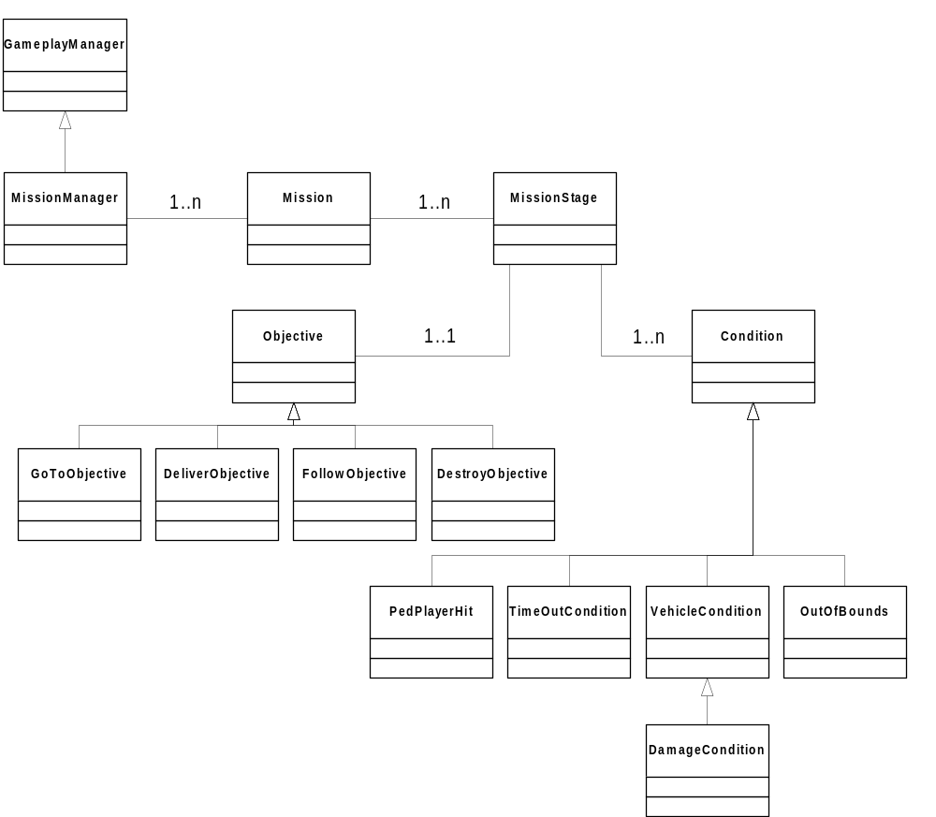

Use Cases
A MissionManager is created at some point, probably when the game first starts up. When the player begins story mode, the MissionManager is instructed to load a level script file with MissionManager::LoadLevelScript.

Once complete, if the player is resuming a game, the mission manager’s Mission is set to the correct stage with the SetToStage method. Otherwise, the first stage in the mission is the default. MissionStage::Initialize is called to place any world objects (the collectibles from the Objective). The MissionStage also saved the current location of the player (and a vehicle if there is one) to the player can be accurately Reset.

The first stage of a Mission should always be a stage with no conditions and the simple objective of moving to the start location for the next mission.

While the mission is in progress, the MissionStage::GetStartMessage text is displayed to remind the player what the purpose of the stage is. When the stage is completed successfully, the MissionStage::GetEndMessage text can be displayed.

The player will also want to know about the mission and the conditions for failure of the mission. A message about a condition can be retrieved from the Condition::GetDescription method.

The MissionManager sits around waiting for messages and passes them off to the current mission stage’s HandleMessage method when it receives them. The MissionStage then passes the message to its Objective and all Conditions. If the objective is satisfied and none of the conditions are violated, the mission stage was successful.

If any of the conditions are violated then the mission has failed. The Condition::GetMessage method is called to display a message to the player describing why the mission failed. The mission stage will call MissionStage::Reset to place the player and any collectibles back at the starting location.

When the Mission sees that a mission stage is complete using MissionStage::IsSuccessful, it calls Mission::NextStage and moves on to the next stage. This calls MissionStage::Finalize to clean up the collectibles from the previous stage and MissionStage::Initialize for the next stage.

When there are no more stages in the mission then the Mission::GetCurrentStage return null and Mission:IsComplete returns true. The MissionManager then tells the game to switch levels or go back to the front end or whatever it needs to do.

